

Name:

HCC 11 Physics
Airbags
Evaluation and Analysis 2014/15

Score: _________ / 30 ______________%

TIME ALLOWED FOR THIS ASSIGNMENT
50 minutes

MATERIAL REQUIRED OR RECOMMENDED FOR THIS TEST
This question and answer booklet
2A/B Physics Formula & Constants Sheet
Pens, pencils, eraser, rule, Mathaid or Math-o-Matt
Scientific calculator
One (1) page, front and back, of handwritten notes

INSTRUCTIONS
Answer all questions and write answers in the spaces provided.

MARK SCHEME
Each answer will be accorded a mark out of five, consistent with the following table:

5 marks | Links multiple concepts clearly to explain real‐life situations in detail. Extracts and manipulates relevant data from a variety of sources. Uses appropriate terminology to describe phenomena.  Correctly and consistently describes, predicts and explains relationships between variables.
4 marks | Applies relevant concepts to explain real‐life situations, but explanations lack detail. Extracts data from a variety of sources and applies it correctly. Describes relationships between data and concepts using appropriate terminology  Correctly describes and predicts relationships between quantities.
3 marks | Links concepts and situations, but does not fully apply principles to explain situations. Correctly extracts straightforward data from graphs, tables and diagrams. Uses a limited range of physics terminology.
2 marks | Recalls principles occasionally, but does not apply them to real‐life situations. Uses a small amount of simple physics terminology, relying mainly on everyday language.
1 mark | Does not refer to Physics principles. Relies on everyday language.
0 marks | Question not attempted.

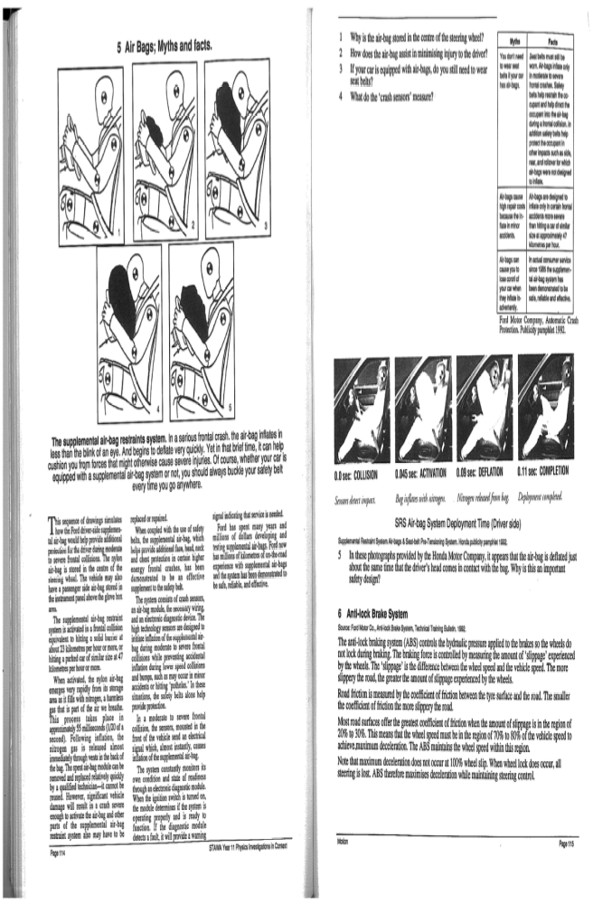
The first inflatable device for crash landings was created for an aeroplane during the Second World War. Airbags began to appear in cars in the 1980s.

1. Airbags work by increasing the time it takes to absorb the shock of an impact. Use Physics principles to explain why this is beneficial for the occupant of a car in a collision.

2. How does the air bag assist in minimising injury to the driver?

3. Why is the airbag stored in the centre of the steering wheel?

4. With airbags now standard in motor vehicles, do you still need to wear a seat belt? In your answer you may disregard the road rules in place; explain using Physics principles whether it is necessary.

5. Air bags require sensors to deploy them. Where are these sensors located, and what do they measure?

6. In these photographs provided by the Honda Motor Company, it appears that the air bag is deflated just about the same time that the driver’s head comes in contact with the bag. Why is this an important safety design?

